**Week 1 Notes**

**Geology**  - study of earth materials and processes.

Historical Geology, Fossils, events

Physical Geology

Stratigraphy

Mineralogy

Earth Processes

Geophysics

Geologic Structures

**Environment**

**1.**  circumstances, objects, conditions by which one is surrounded

**2a** **:**  the complex of physical, chemical, and biotic factors acting upon an organism or an ecological community and determine its form and survival

**2b** **:**  the aggregate of social and cultural conditions that influence the life of an individual or community

**Environmental Geology** is an applied science.

Applies the principles of geology and ecology in understanding environmental issues & solving environment related problems.

**Environmental Disasters** lead to environmental laws. Oils spills in CA, Love Canal, Valley of the Drums, Chernoybl, Exxon Valdez and BP oil spills, Bophal India chemical disaster

**Big Picture Theories & Ideas**

Big Bang - Universe

Origin of Elements in Stars

Origin of Planets

Geologic Time

Evolution – Origin of Life

Origin of Atmosphere

Origin of Oceans

**Big Bang** – 13.77 billion years ago, all matter is condensed into one spot and quickly expands sending matter and energy through the universe. Evidence of the ‘Big Bang” includes red shift, cosmic microwave background radiation and universal make-up.

* You Tube - http://www.youtube.com/watch?v=oLMrybV-6ys
* Millions of years after the Big Bang, matter is pulled together by gravity to form nebulas, stars and galaxies

**Stars produce “heavy” elements like carbon and iron**. The larger the star the shorter its life and the greater ability it has to produce heavier elements. <http://www.youtube.com/watch?v=uKqvjEE0wFg&feature=related>

* Our Solar System forms 4.5 billions years ago by contracting and spinning of solar nebular

**Planets in Solar System - M, V, E, M, AB, J, S, U, N, P**

* MVEM called “inner planets,” made of rock
* JSUNP, called “outer planets,” made mostly of gasses and ice
* **The Solar System and Earth are about 4.5 billion years old**.
* Date based on ages of rocks on earth, the moon and meteorites (three independent lines of evidence).
* **Basic Principle of Geology - EARTH IS VERY OLD!**

**Geologic or “Deep Time”** an important concept

* Earth is about 4.5 billion years old the rocks hold the story of what happened over this time period
* We will consider “recent” events
* Recent means the last 12,000 yrs, and studies of Environmental Geology usually focus on recent events
* **Holocene(today) and Pliestocene (Ice Age) ended 12,00 years ago**
* **Rocks hold the only information about what happened over time**
* **Study of rocks billions of years old allows us to “see” into the past**

**Origin of Air, Water and Life on Earth**

* Related to volcanic and other processes we see today includes photosynthesis.
* The volcano eruption rate higher when earth was young and hotter. Plate “recycling” continues to add water, CO2 etc..
* Magma 1-5% dissolved gas

**As Earth cooled, H2O produced by volcanic out gassing could exist as liquid allowing oceans to form**

* + Evidence – Old rocks include pillow basalt &, deep marine sediments..
  + Time - over billions of years the water accumulated
  + Minerals inside earth contain lots of water
  + Collision of the earth with icy comets may have also contributed sigificant amounts of CO2 and H2O. Recent NASA comet study.

**Evolution of Atmosphere – today 78% N, 21 % O, 1% other gases including CO2**

**First Atmosphere**

Composition - Probably H, He These gases are relatively rare on Earth compared to other places in the universe and were probably lost to space early in Earth's history: Earth's gravity not strong enough to hold lighter gase. Earth still did not have a differentiated core (solid inner/liquid outer core) which creates Earth's magnetic field (magnetosphere = Van Allen Belt) which deflects solar winds. Once the core differentiated the heavier gases such as CO2 could be retained

**Second Atmosphere -** Produced by *volcanic out gassing.*

Gases produced were probably similar to those created by modern volcanoes (H2O, CO2, SO2, CO, S2, Cl2, N2, H2) and NH3 (ammonia) and CH4 (methane). No free O2 at this time (not found in volcanic gases).

**Last Stage - Addition of Oxygen**

Today, the atmosphere is ~21% free oxygen. How did oxygen reach these levels in the atmosphere?

**Oxygen Production**

**Photochemical** **dissociation** - breakup of water molecules by UV light

* + Produced O2 levels approx. 1-2% current levels
  + At these levels O3 (Ozone) can form to shield Earth surface from UV

**Photosynthesis** - CO2 + H2O + sunlight = organic compounds + O2 -produced by cyanobacteria, and eventually higher plants - supplied the rest of O2 to atmosphere.

***Plants gave us the O2 rich atmosphere we have today.*** Earth’s Atmosphere has been as it is today for about 400 million years.

**Origin of Life From elements – Non-Living**

* **Oxygen prevents growth of the most primitive living bacteria**
* **Since today's most primitive life forms are anaerobic (no oxygen), the first forms of cellular life probably had similar metabolisms.**
* **Today these *anaerobic* life forms are restricted to anoxic (low oxygen) habitats such as swamps, ponds, and lagoons.**
* **Miller experiments (organic soup) – Mixed gases that made up early atmosphere (no oxygen) in container and added electricity (lightning) – made amino acids and other organic building blocks of life**
* **Conclusion - amount of O2 in the atmosphere has increased with time due to plants.**
* **Only last 10% of Earth history had atmosphere like today…last 400 million years….**

**Evolution or Modification by Descent**

All life evolved from other forms of life. Anerobic Bacteria was the first life form.

Man did not come from monkeys. Man and Apes have a common ancestor. Below is from Wiki.

* 3.8 billion years of [simple cells](http://en.wikipedia.org/wiki/Prokaryote) (prokaryotes),
* 3 billion years of [photosynthesis](http://en.wikipedia.org/wiki/Photosynthesis),
* 2 billion years of [complex cells](http://en.wikipedia.org/wiki/Eukaryote) (eukaryotes),
* 1 billion years of [multicellular life](http://en.wikipedia.org/wiki/Evolution_of_multicellularity),
* 600 million years of simple [animals](http://en.wikipedia.org/wiki/Animal),
* 570 million years of [arthropods](http://en.wikipedia.org/wiki/Arthropods) (ancestors of insects, arachnids and crustaceans),
* 550 million years of complex animals,
* 500 million years of [fish](http://en.wikipedia.org/wiki/Fish) and proto-amphibians,
* 475 million years of [land plants](http://en.wikipedia.org/wiki/Land_plant),
* 400 million years of [insects](http://en.wikipedia.org/wiki/Insect) and [seeds](http://en.wikipedia.org/wiki/Seed),
* 360 million years of [amphibians](http://en.wikipedia.org/wiki/Amphibian),
* 300 million years of [reptiles](http://en.wikipedia.org/wiki/Reptile),
* 200 million years of [mammals](http://en.wikipedia.org/wiki/Mammal),
* 150 million years of [birds](http://en.wikipedia.org/wiki/Bird),
* 130 million years of [flowers](http://en.wikipedia.org/wiki/Flower),
* 65 million years since the non-avian [dinosaurs](http://en.wikipedia.org/wiki/Dinosaur) [died out](http://en.wikipedia.org/wiki/Cretaceous%E2%80%93Tertiary_extinction_event), and primates appear
* 2.5 million years since the appearance of the genus [*Homo*](http://en.wikipedia.org/wiki/Homo_(genus)),
* 200,000 years since [humans](http://en.wikipedia.org/wiki/Homo_(genus)) started looking like they do today,
* 30,000 years since [Neanderthals](http://en.wikipedia.org/wiki/Neanderthal) died out.

Darwin observed fossils and living animal (finches and others) adaptations.

* Like earth processes, Darwin argued that forces in biology (reproduction, inheritance, competition, environment) gradually produced the changes in life forms we see preserved in the fossil record.
* Darwin saw evidence of evolution, **but did not know the cause**. DNA studies came later and make evolution a SLAM DUNK!

Based on observations above Darwin made the following conclusions

* + There is variation in heritable traits in all living things due to sexual reproduction
  + Some of the variability passes between generations
  + Competition exists because more offspring are produced than survive. Selection pressure… survival strategy
  + Surviving to adulthood and reproductive success are not random events. “The fittest survive.”

Quotes from Sean Carroll

* “We may marvel at the process of an egg becoming an adult, but we accept it as an everyday fact. It is merely then a lack of imagination to fail to grasp how changes in this process that are assimilated over long periods of time, far longer than the span of human experience, shape life’s diversity.”
* “Evolution is as natural as development.”

**Human Evolution**

1. **Intermediate forms between ape-like ancestors and humans should be found in the fossil record. No Missing Links (see chart below)**
2. **We should have vestigial organs**
3. **Apes and humans should share similar genetic characteristics.** When compared to other animal’s, the human genome should be most similar to Apes. We should find unique sequences of DNA that are mutually exclusive to human and Ape genomes.
4. **We should find environmental changes that correspond to the time hominids diverged from apes.**

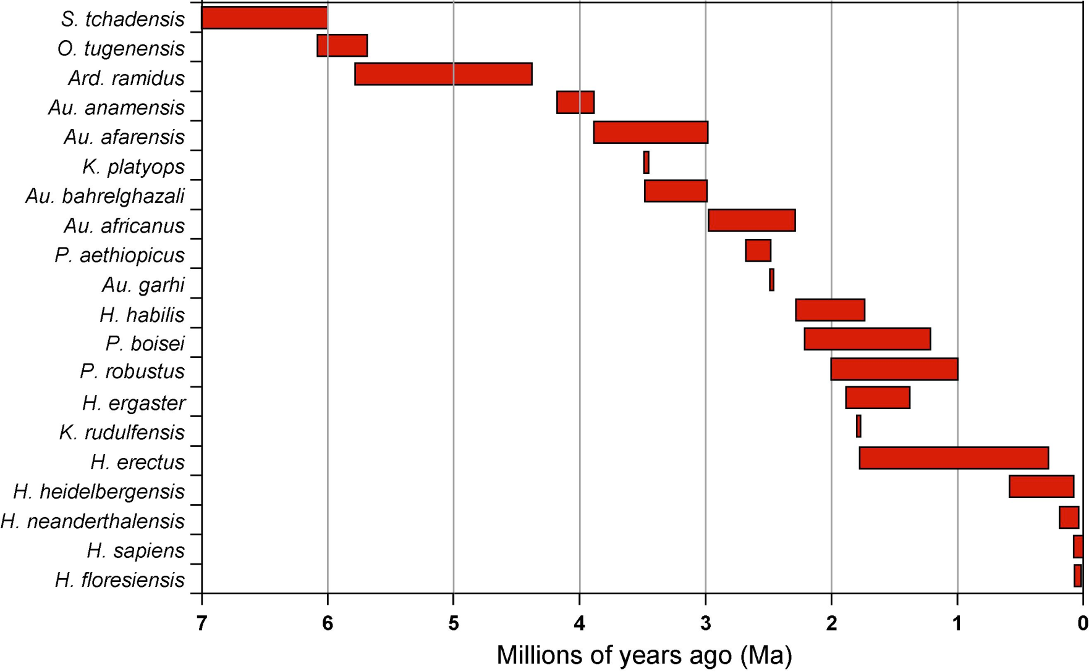

**Main Ideas Used In Environmental Studies**

* Population Growth
* Sustainability
* Systems and Energy
* Uniformitarianism
* Geologic Hazards
* Scientific Method

**Population**

* 3rd World Growth Rate = 3%
* USA, Europe rate is 1% or less, some counties decrease (Russia)
* World rate is 1.1%
* 70/1.1% = 62 years - World
* 70/3% = 23.3 years - 3rd world
* 70/1% = 70 years – USA
* 70/1.5-3% = 46-25 Years – Utah
  + Utah current population is 2,817,000
  + Utah growth rate is 1.5 to 3%
  + At 2% the population of Utah will be 5.6 million in 2047.

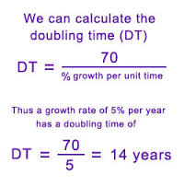

* World population reached 1 billion in 1850
* 2 billion in 1930 – 80 yrs
* 3 billion in 1960 – 30 yrs
* 4 billion in 1975 – 15 yrs
* 5 billion in 1987 – 12 yrs
* 6 billion in 1999 – 12 yrs
* 7 billion in 2012 – 12 yrs
* What is the trend??? - exponential
* At this rate there will be 10 billion people by 2046
* How old will you be?
* How old will you kids be?
* How will the world look?

**Are There Limits to Growth and Consumption?**

* Population growth, industrial expansion & high standards of living consume natural resources and create other issues (immigration, economics).
* Developed countries (USA, Canada, Japan, China, Europe etc.) use more resources/person, but other countries have large populations India, Africa etc
* Many resources are nonrenewable/not unlimited and can be produced only at certain rates.

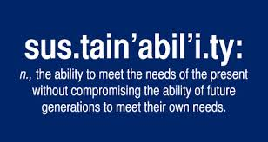

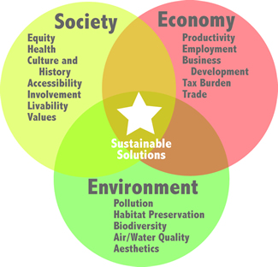

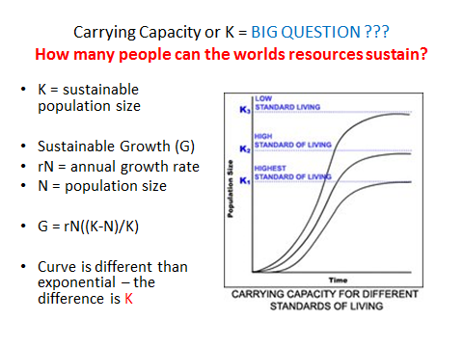

**Main Concept 3 – Earth Systems**

System - a set of connected things or parts forming a complex whole

* + Open – Living things maintain a steady state by using energy and resources
  + Closed – Non living things (earth, sun etc.), the system slowly runs down
* Energy – Ability to do work or cause change
* Laws of energy
  + Energy comes in many forms
  + Energy can change forms
  + When it changes, energy spreads out or is less able to do work/cause change

Plate Tectonic System and Environment

Creates land

Causes natural hazards

* + Earthquakes
  + Volcanoes
  + Mountains

Creates Geologic Resources (oil, gas, hydrothermal energy, minerals)

Life and Ecology

Evolution

Hydrologic System and Environment

* + Surface Water and Groundwater Water
  + Erosion
  + Soil
  + Natural hazards – floods, landslides, tornados, hurricanes
  + Life and Ecology
  + Climate
  + Evolution

**Uniformitarianism – Important Concept**

**Uniformitarianism includes Three Main Parts**

1) We can interpret the rock record (understand earth history) by observing current geologic processes.  In other words, assume earth process (laws of nature) have remained same over time.

2) Constant geologic processes operate slowly in terms of a human life, but add up to big changes over long time periods.

3) Application of uniformitarianism implies a VERY old earth.

* + Example: Rivers and the Wasatch Mtns

Environmental Application of Uniformitarianism

* What people do today can be used to predict what may happen **or what not to do** in the future..
* Population development etc.
* If we can predict we make plans and do something about it… climate change etc…

**Main Concept – Geologic Hazards**

* Annual deaths 31 to 320,000 from Earthquakes in 2000 to 2012 – minimum damage from Japan EQ 15 billion
* Annual damage ($1 billion) and death (25-50) from Landslides in USA
* Annual Damage ($3 billion) and Death (400) from Volcanoes
* Also look at Floods, Hurricanes and Tornadoes (Hydrologic system)

**Main Concept – Scientific Method and Critical Thinking**

* A process used to explain the natural world.
* Science is based on facts, and measurements. Science follows the data and goes where the data leads. Sometimes the process can be complex (evolution, climate change)
* Feelings and intuition do not count (officially) in science.
* Science and Geology - We can’t go back in time and reproduce events. We observe the old rocks (history book) and describe what happened in the past based on current processes. This sets geology apart. Each process and time period leaves either a deposit or record of erosion

**Not all questions can be addressed by science**

Science applies only to questions or topics that can be studied by collecting data and making observations. Science studies must be repeatable. This means science can be faked or falsified. If the subject is something that can’t be measured or repeated by others, it’s not a subject that can be studied using the science. This separates science from religion.

* + - Non-falsifiable hypothesis – God created the Earth. We can’t use non-measurable or supernatural explanations in science.

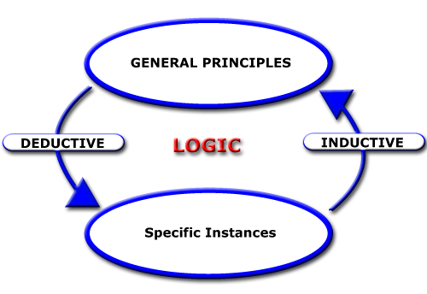

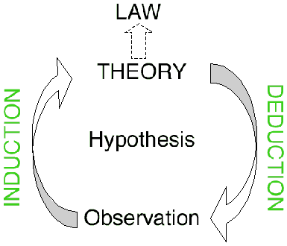

**Invalid Arguments** include Attacking the Man, Argument by Authority etc..

**Science Process – Four Things to Consider**

1. Falsifiability

**2.** Independence - means multiple lines of evidence lead to the same conclusion**.** Each line of evidence is independent or stands on its own. The lines of evidence are used to form an explanation or theory.

* + Examples – murder scene, DNA, rocks in So Ut and So CA

3. Repeatabilitymeans data used to quantify or describe the discovery must be repeatable by other scientists.

4. Representativeness – Samples or data must be collected in the right way and at the right time etc. You can’t make valid conclusions or decisions without valid data or enough data.

Model and hypothesis can usually be used interchangeably.

Models take many forms and help us understand things we can measure, but can’t see (atoms, gravity), things that happened long ago (dinosaurs) and very large scale (earth) things. Without models that help us predict and visualize, could not study atoms, stars, brain functions etc.

***A Theory is an INDEPENDENT very well validated explanation*** based on many hypothesis (lines of evidence) and thousands of laws/facts that has undergone numerous tests over time and has held up under many conditions. Theories are widely accepted by the science community.

Theories take decades if not centuries to fully develop.

Precision, Accuracy and Quality Control

Quality Control – This is part of the data collection process used to make sure your data is accurate, precise, representative and repeatable. Allows you to document experiments and measurements so they can be independently verified and repeated.

Accuracy – finding a real value – hitting the center of a target – find out if the data collection **results** are good. Usually set a standard such as; “accuracy must be within 80% to 120%.”

Precision – being able to hit the target several times in the same place (shows consistency of measurement or sampling technique – find out if the data collection **process** is good). Usually set a standard such as; “data must have a precision of + or - 25%.”

Representativeness – collecting samples in the right place at the right time, and in the right amount and in the right way. Avoiding outside contamination is an issue.

Science is frequently used in decision making. As a general rule - the more data or information you have the easier it is to make a good decision (fewer uncertainties). Collection of data requires time and money. Pesky management types want “do more with less.” This can leads to “risky” decisions.

How confident are we in our predictions? Science also allows for stating uncertainties.

* + - Example: We are fairly certain where most earthquakes are likely to occur and how big the earthquakes may be, but we are very uncertain (in terms of year by year) WHEN the earthquakes will occur.

**Uncertainty**: “A state of having limited knowledge where it is impossible (based on existing data) to exactly describe an existing state or future outcome. This means there may be more than one possible outcome.”

* + Many scientific conclusions are stated in terms of uncertainty: For example, the USGS says there is a 60% chance of a magnitude 6.5 earthquake in the San Francisco area within the next 30 years.
  + This statement quantifies uncertainty, but it also allows people to make decisions (should the mayor of San Francisco spend part of his budget on earthquake preparedness etc..).

Precautionary Principle, Uncertainty and Decision Making

1. Take Action to Solve a Problem. We should not wait to act because there is uncertainty in science. Tobacco, Climate Change, Ozone
2. Prevent Problems. Moves burden of proof from the public to the person taking action. Drug company, FDA etc.

Critical Thinking – “This sign has Sharp Edges”